**WEEK 9**

**Using**[**docker compose**](http://10.11.1.19/tessellator50/mod/resource/view.php?id=6738)**to run multiple services and minikube to create nodes.**

**BY ANGELENA  
22BD1A0585**

1. **Create a yaml file with the name docker-compose**

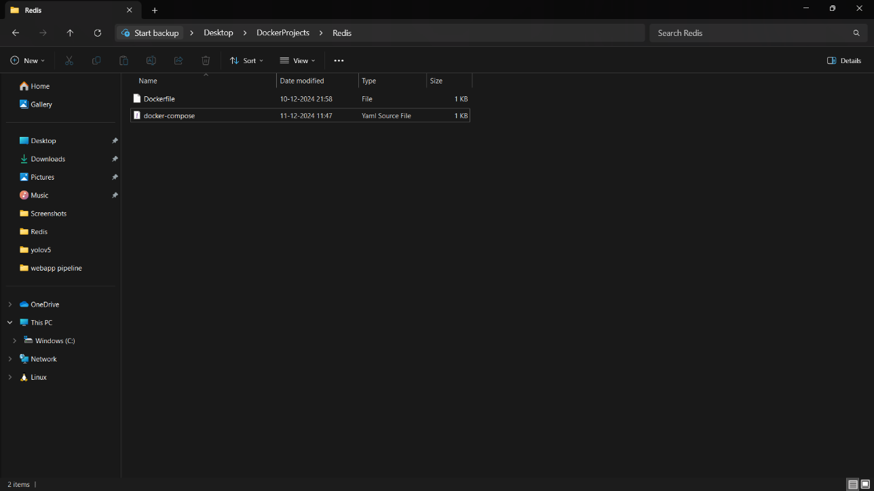

1. **Write the following code in the file with proper indentation**

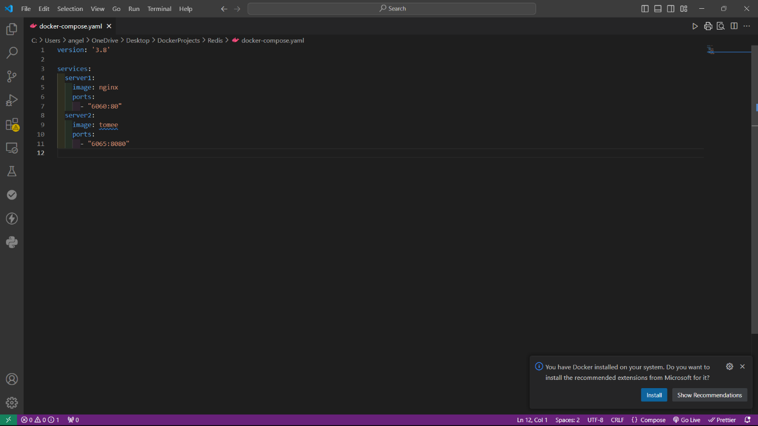

1. **Navigate to the folder directory and run the file as shown**

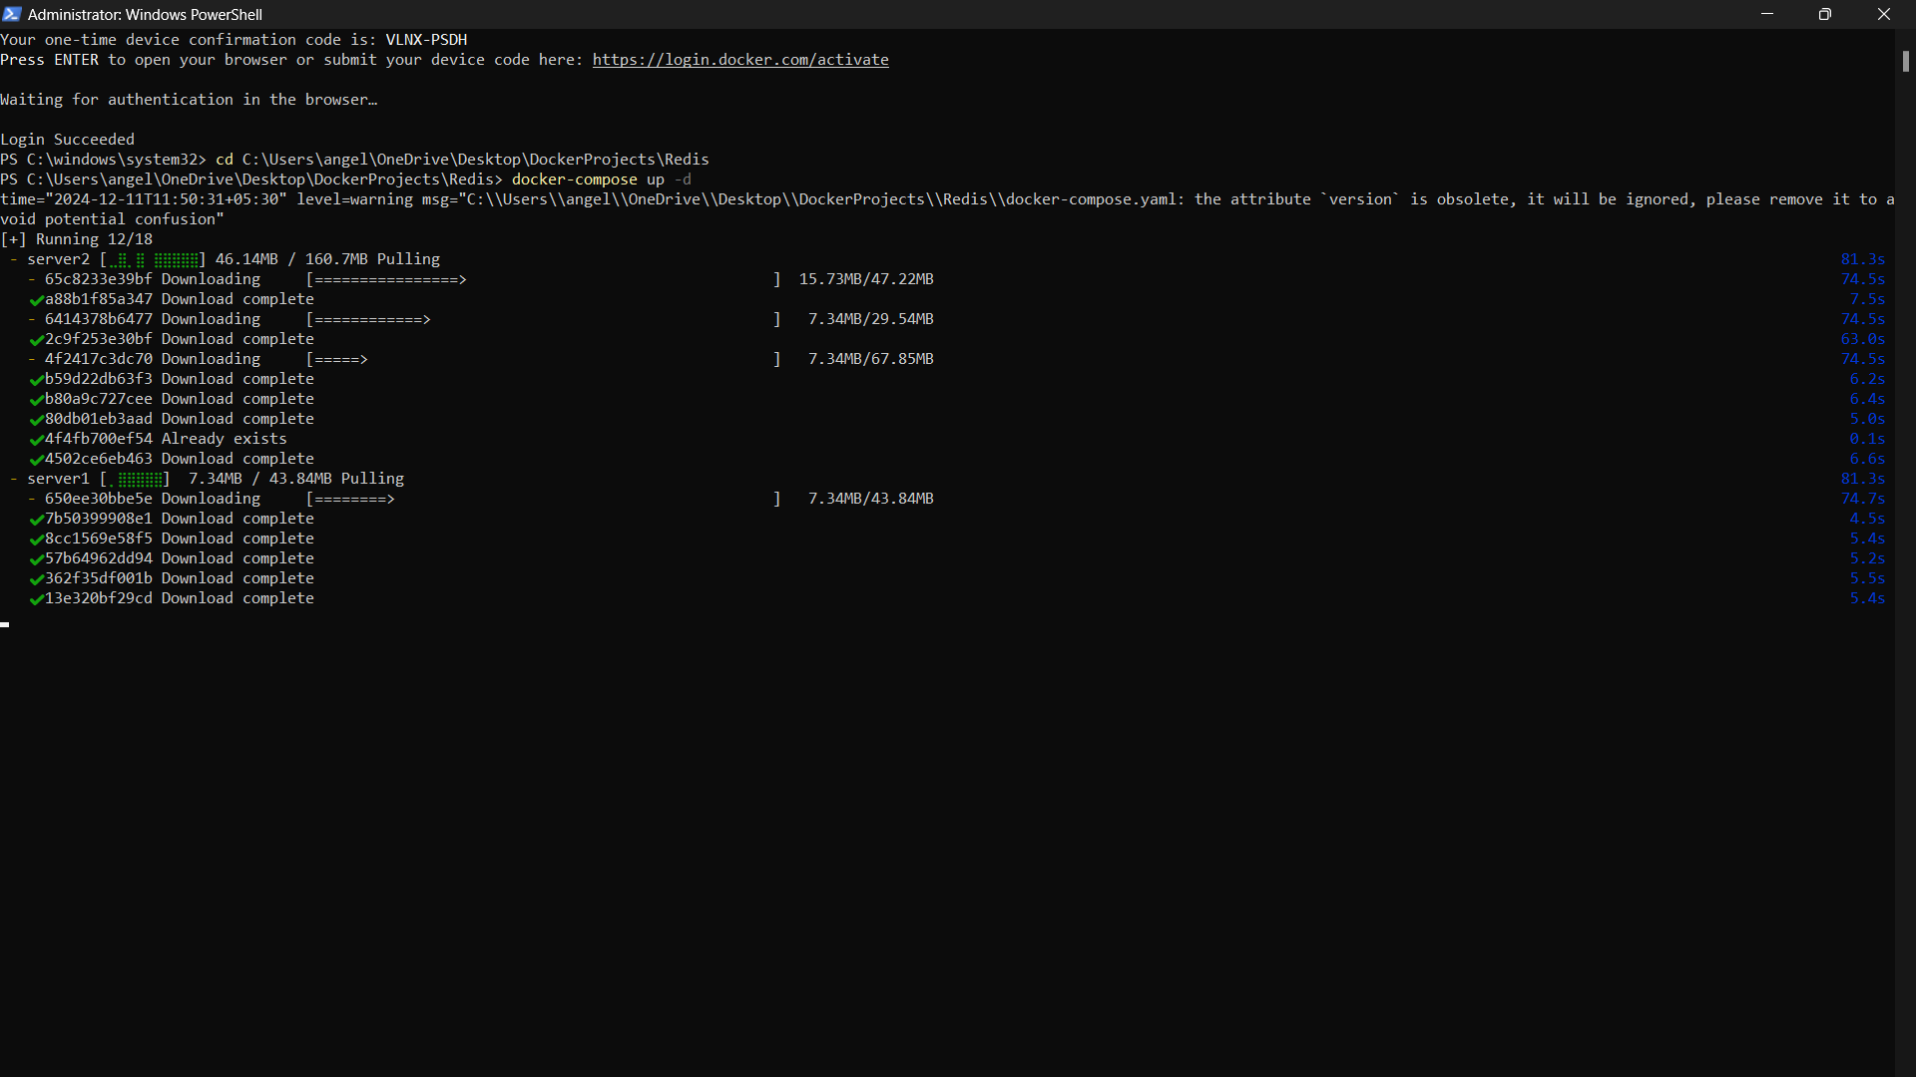

1. **Once you see all green ticks, open the port you mentioned in the code**

**And you will see tomcat home page.**

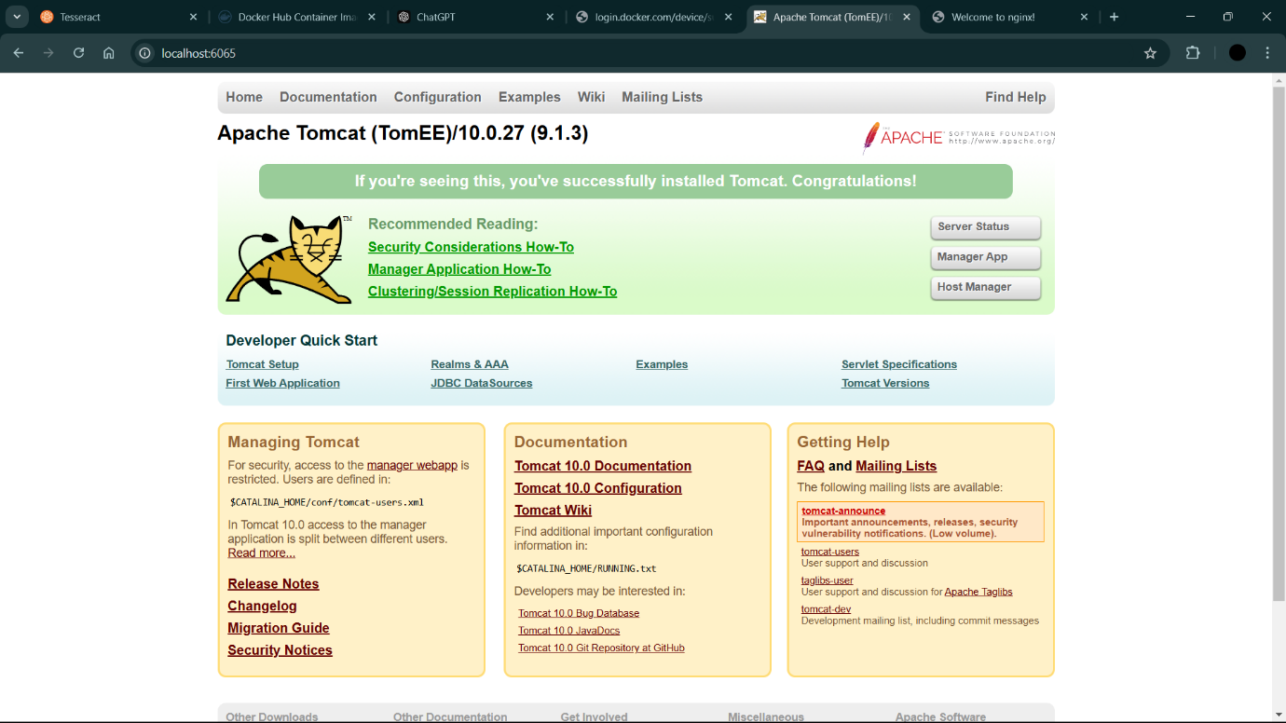

1. **Open the other port and you should see this message**

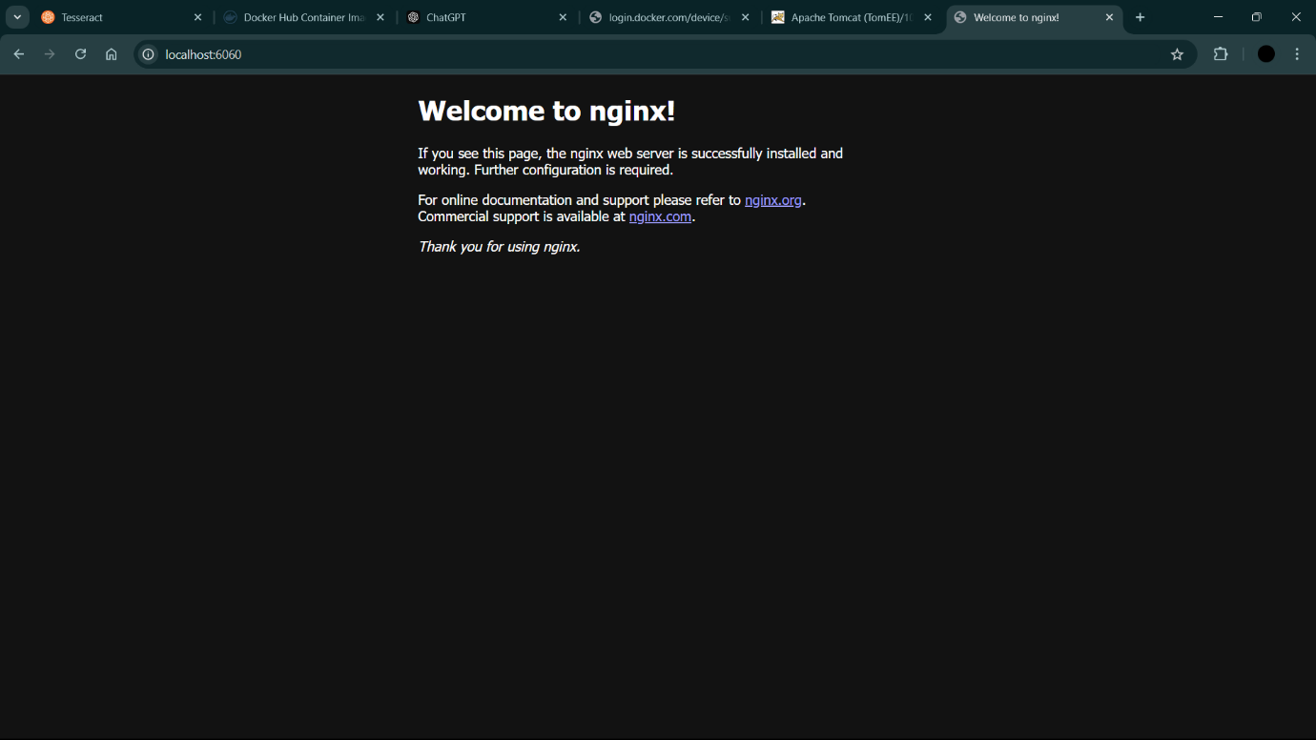

1. **Go to powershell**

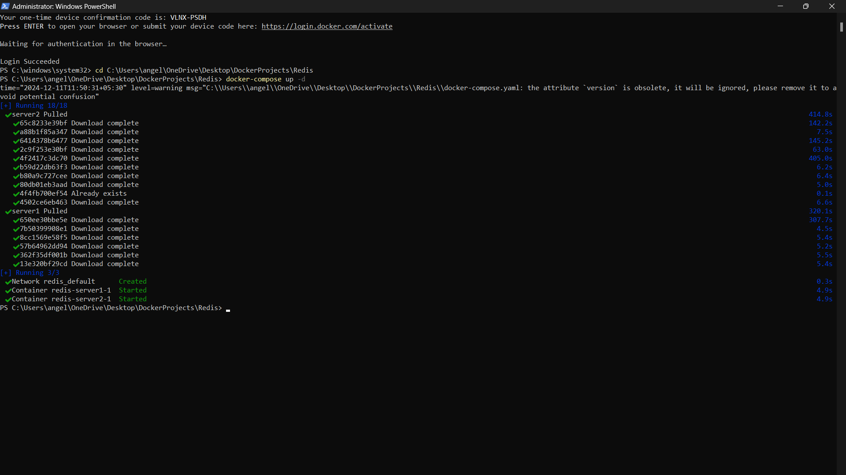

1. **You can stop by using docker-compose stop**

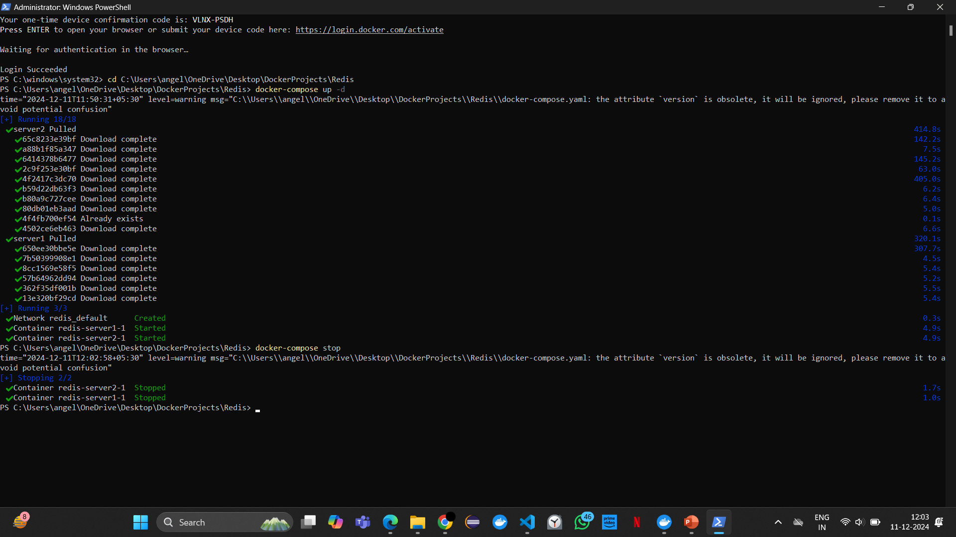

1. **You can start again by using docker-compose start**

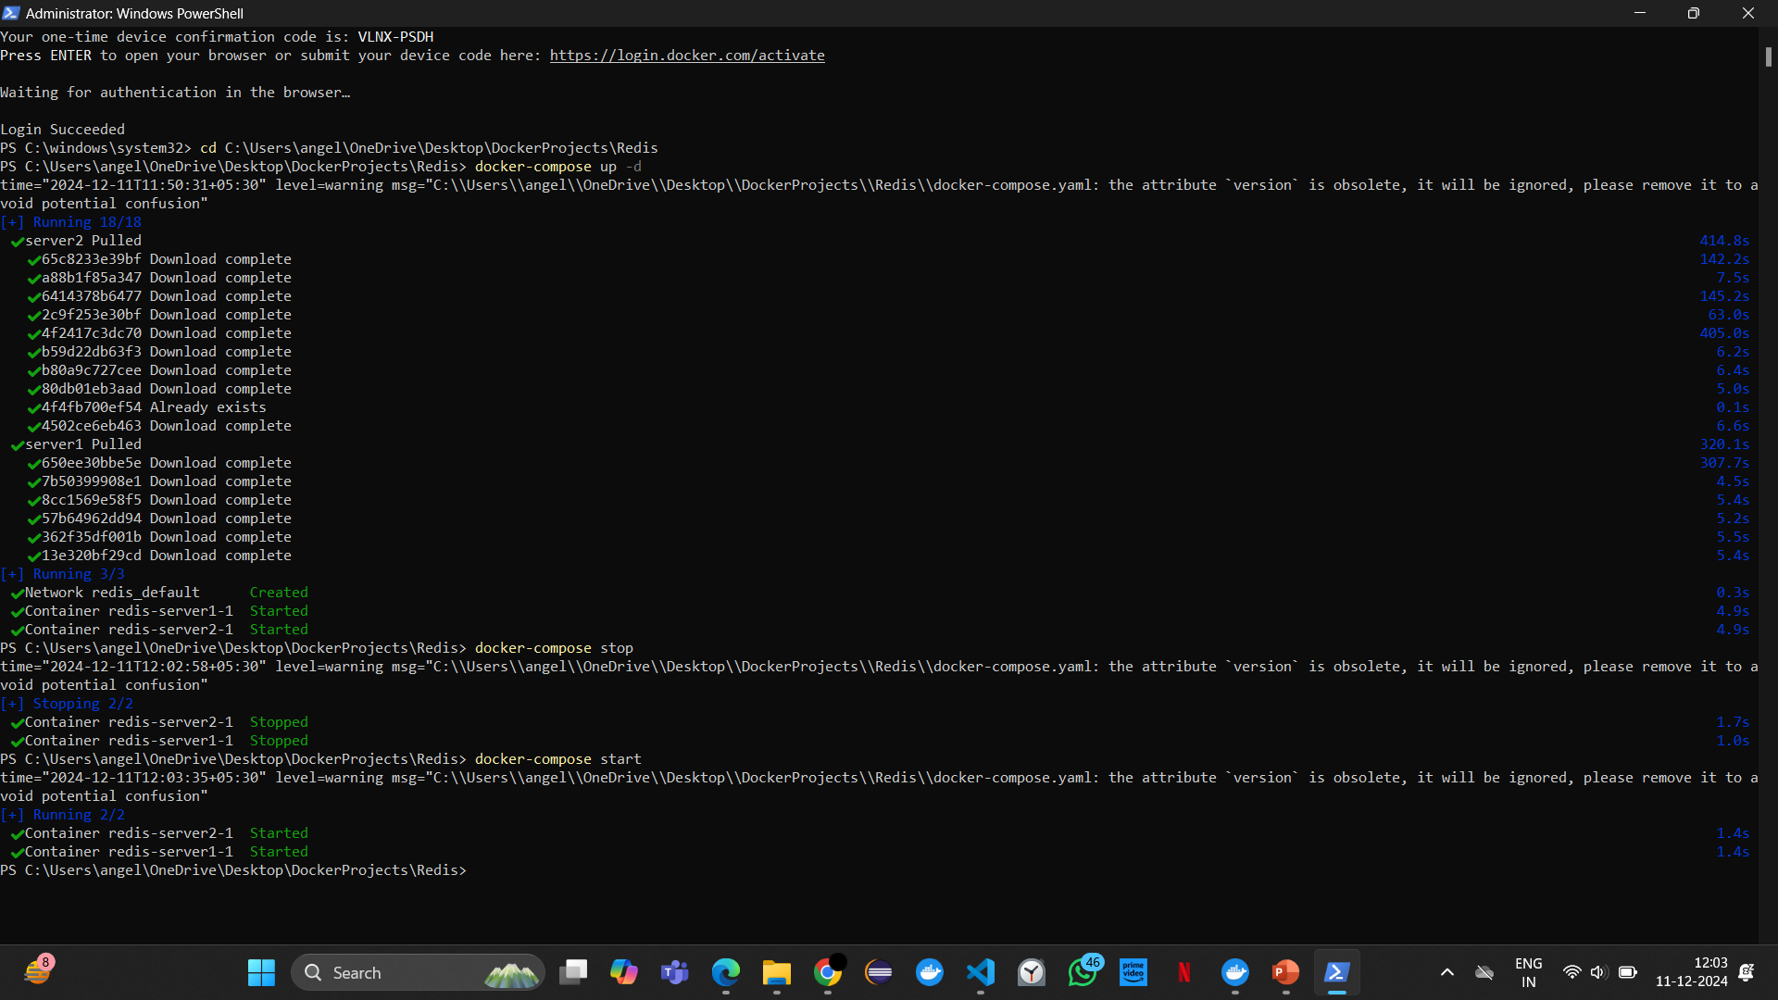

1. **You can remove by using docker-compose down**

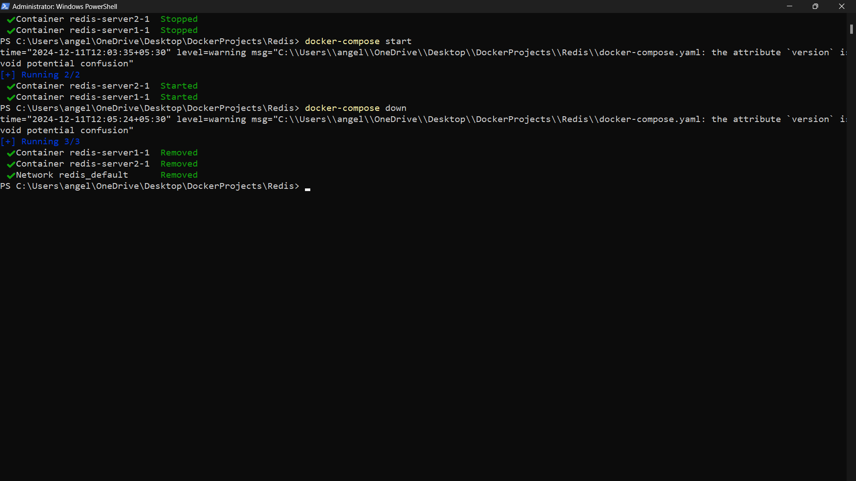

**MINIKUBE TO CREATE NODES**

**DEPLOYING AND SCALING APPLICATIONS USING MINIKUBE**

**1.Minikube start**

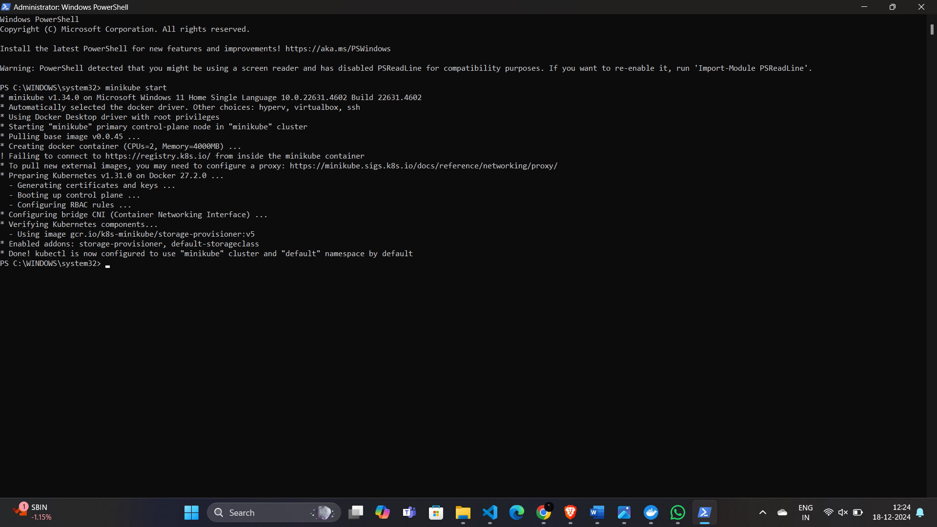

**Step 2: Create and manage the Nginx Deployment**

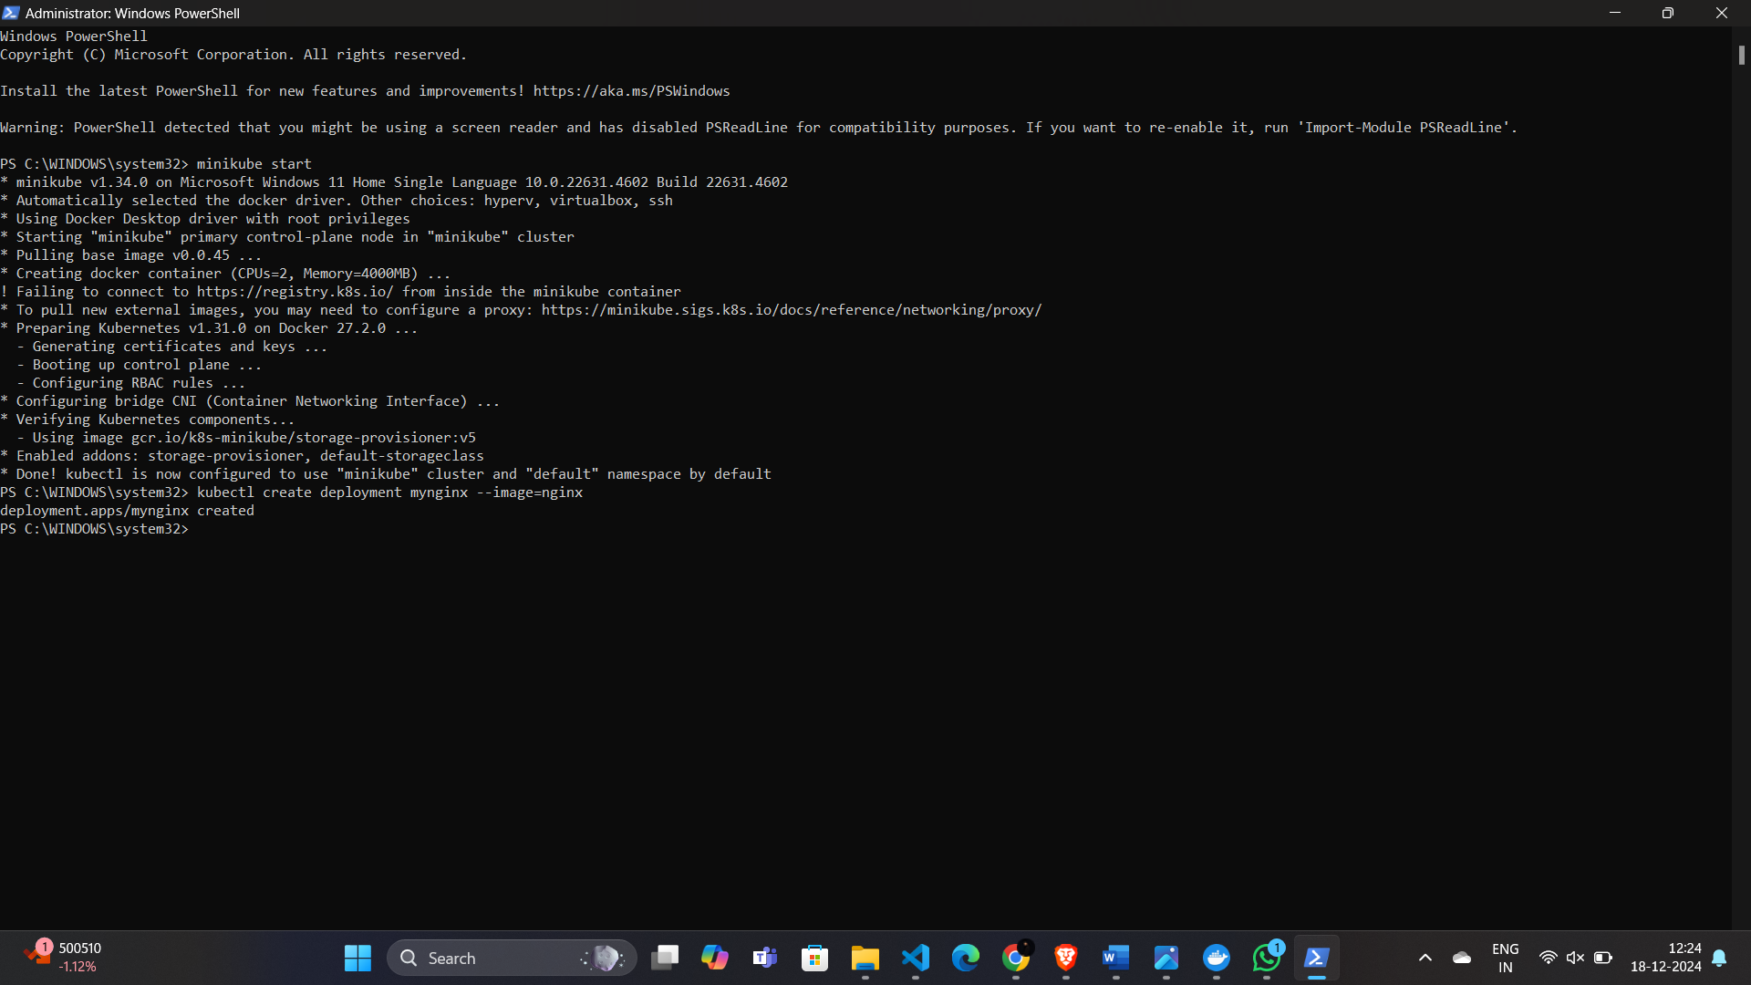

**kubectl get deployments**

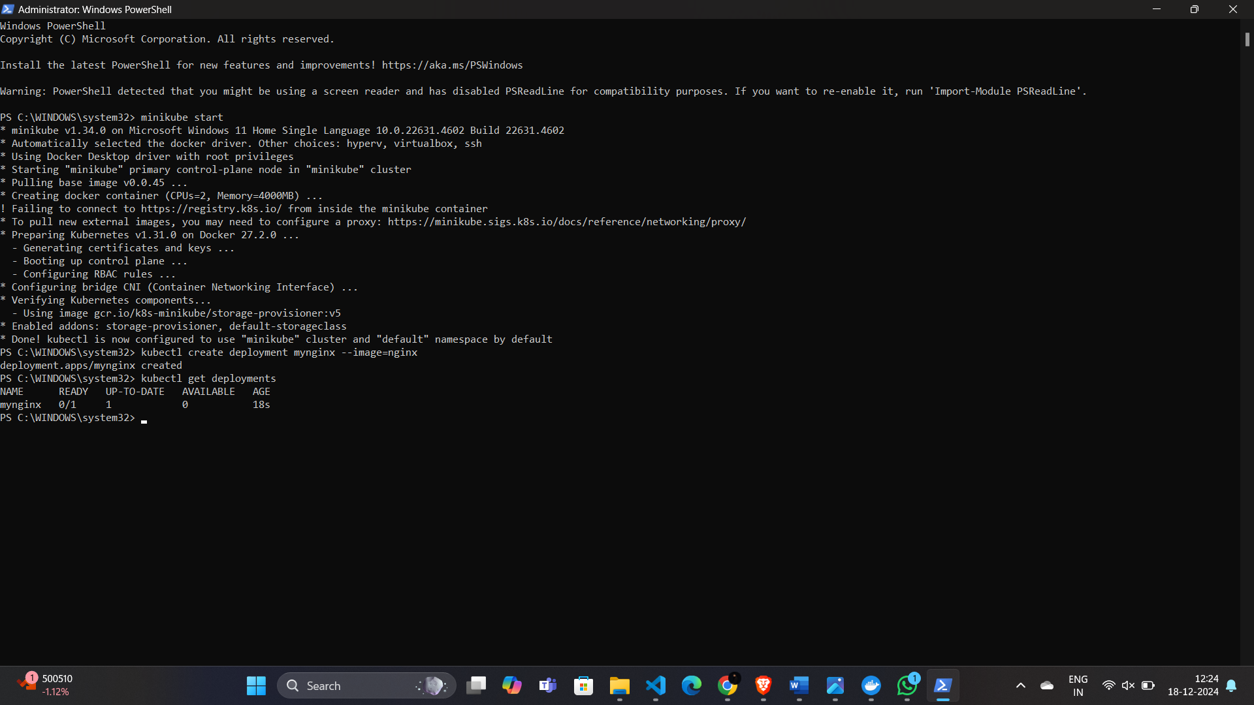

**Step 3: Expose the Nginx Deployment to the Outside World  
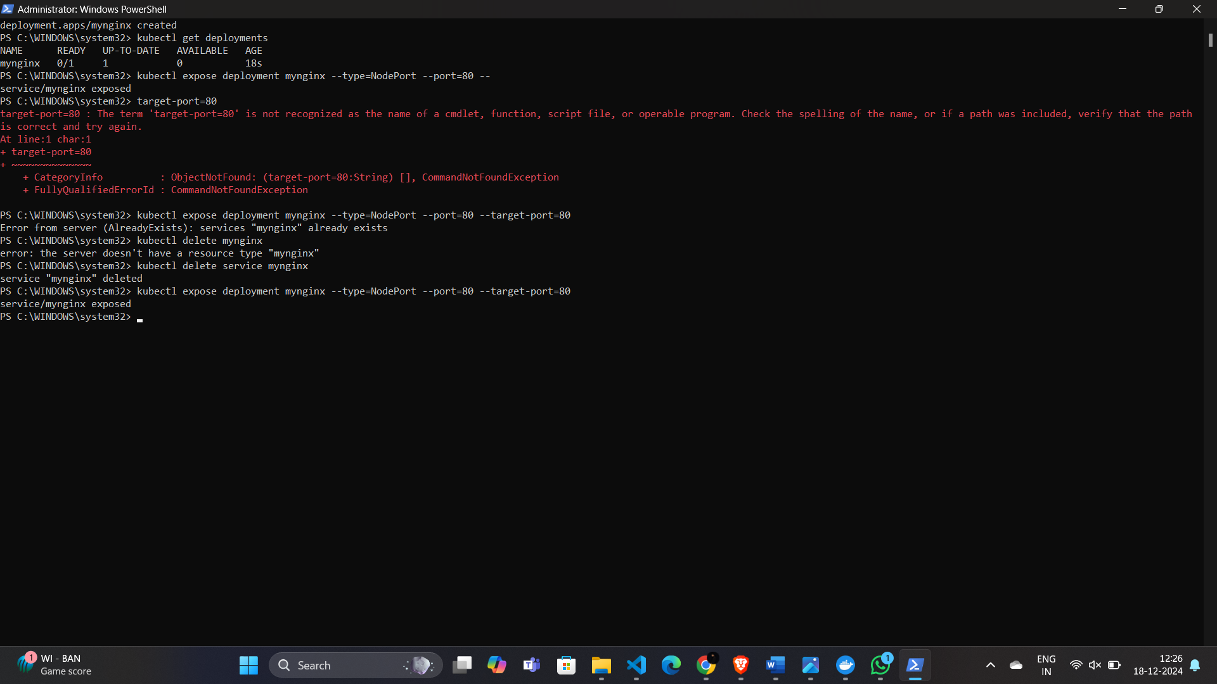**

**Step 4: Scale the Deployment (Make More Copies**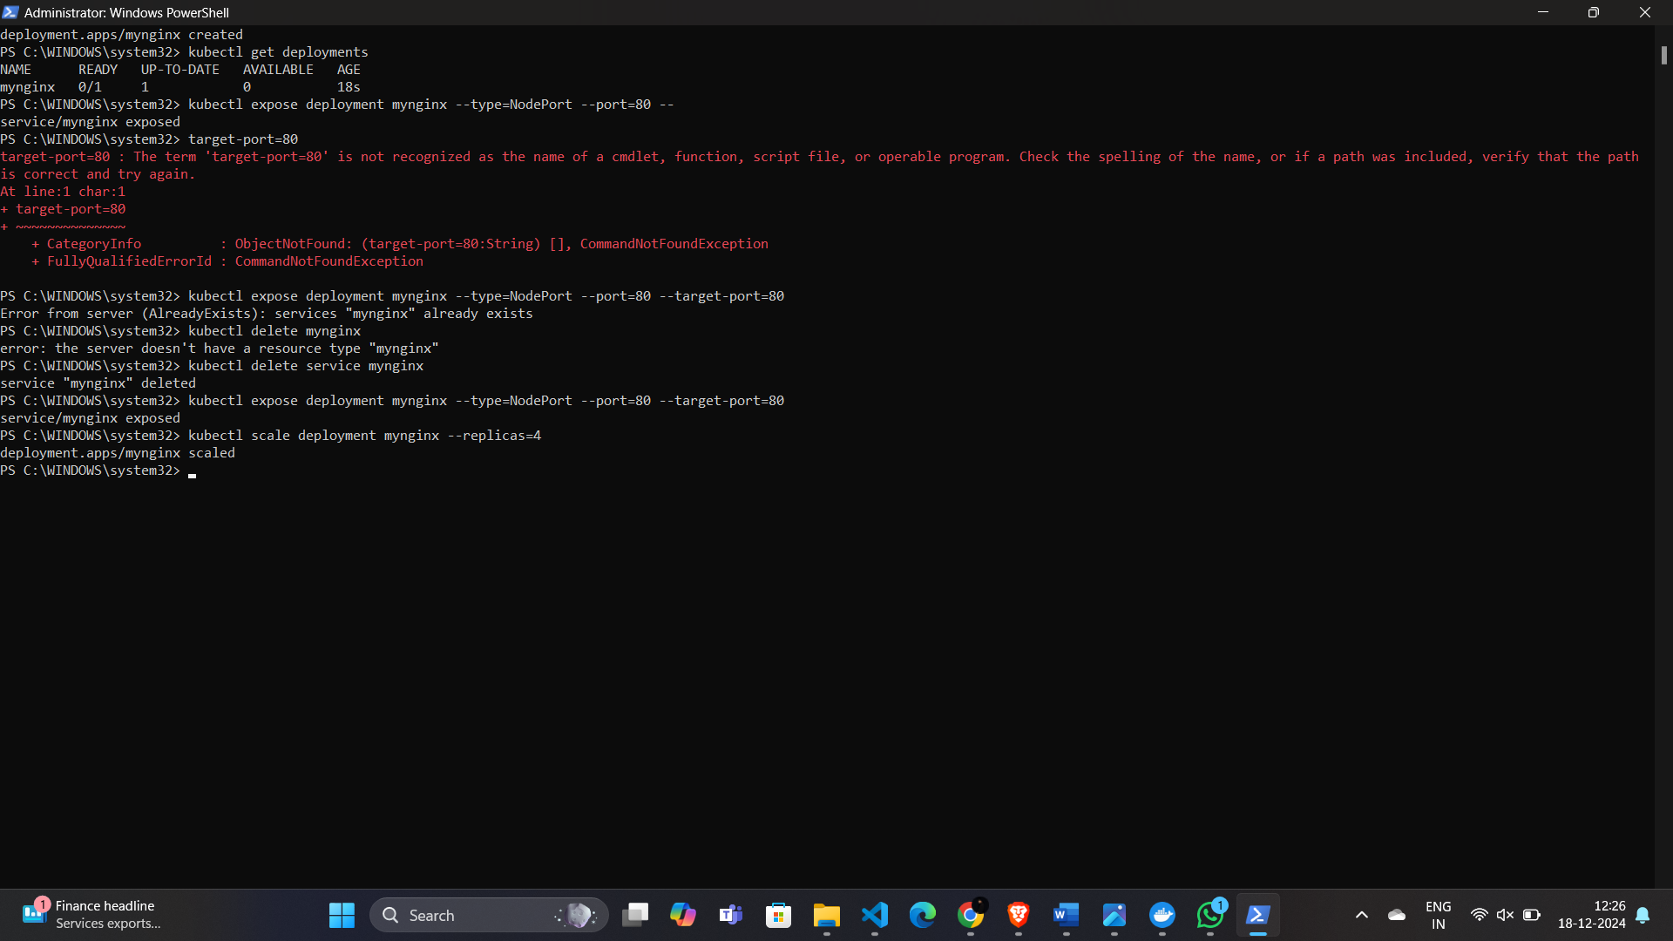

**Step 5: Accessing the Nginx App**

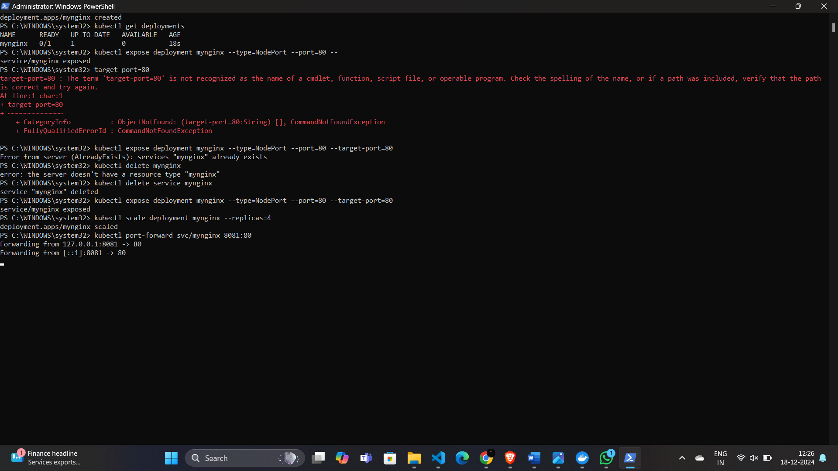

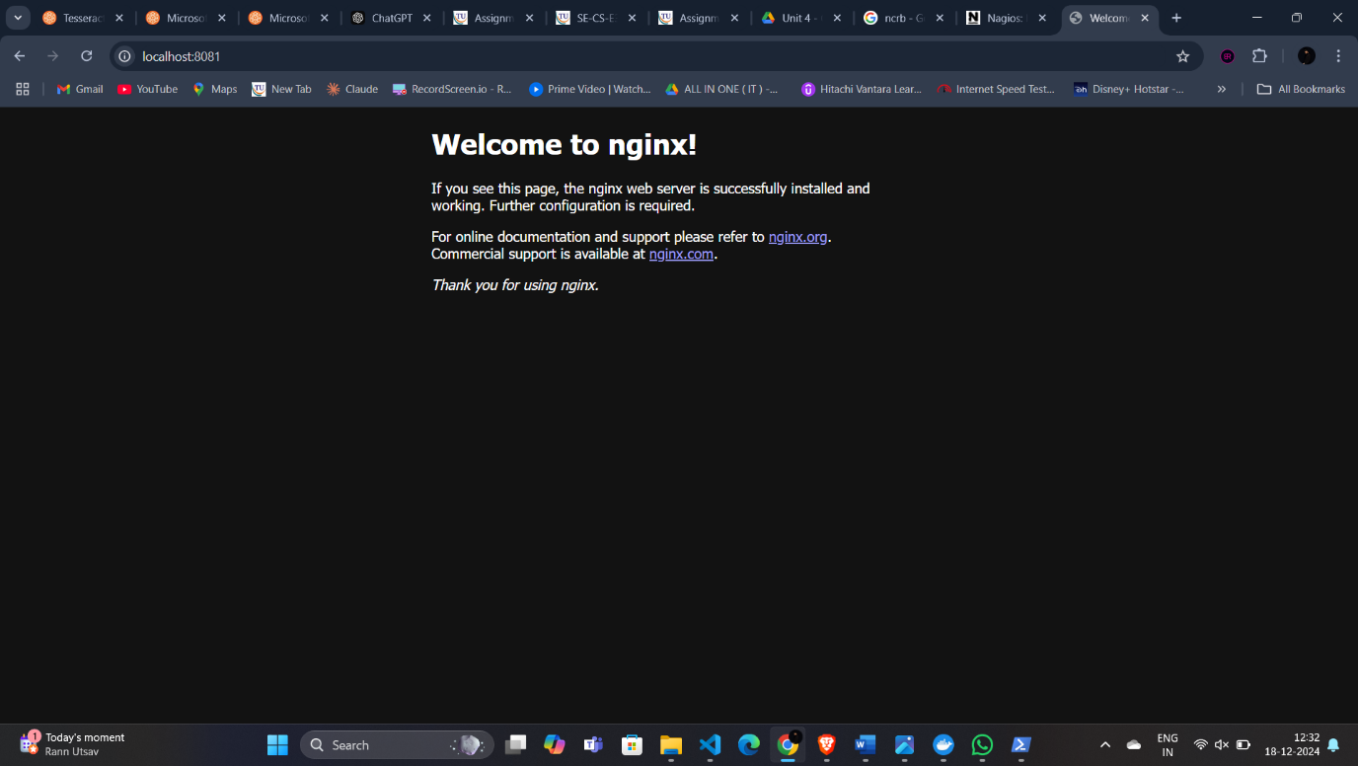**Step 7: Stopping and Cleaning Up Everything**

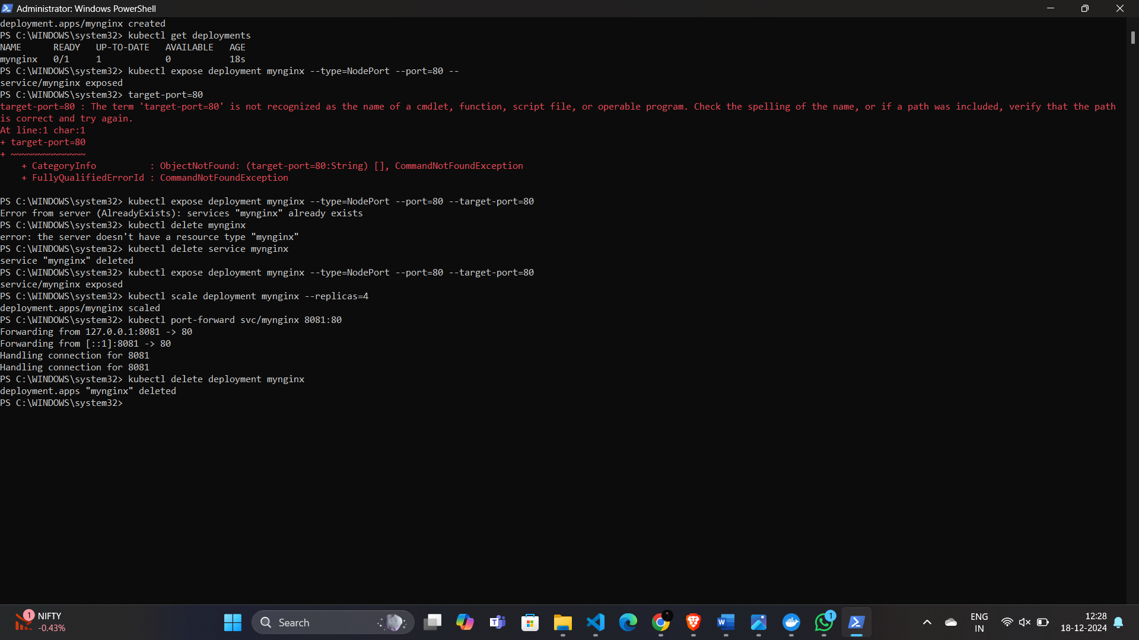

**Kubectl delete service mynginx**

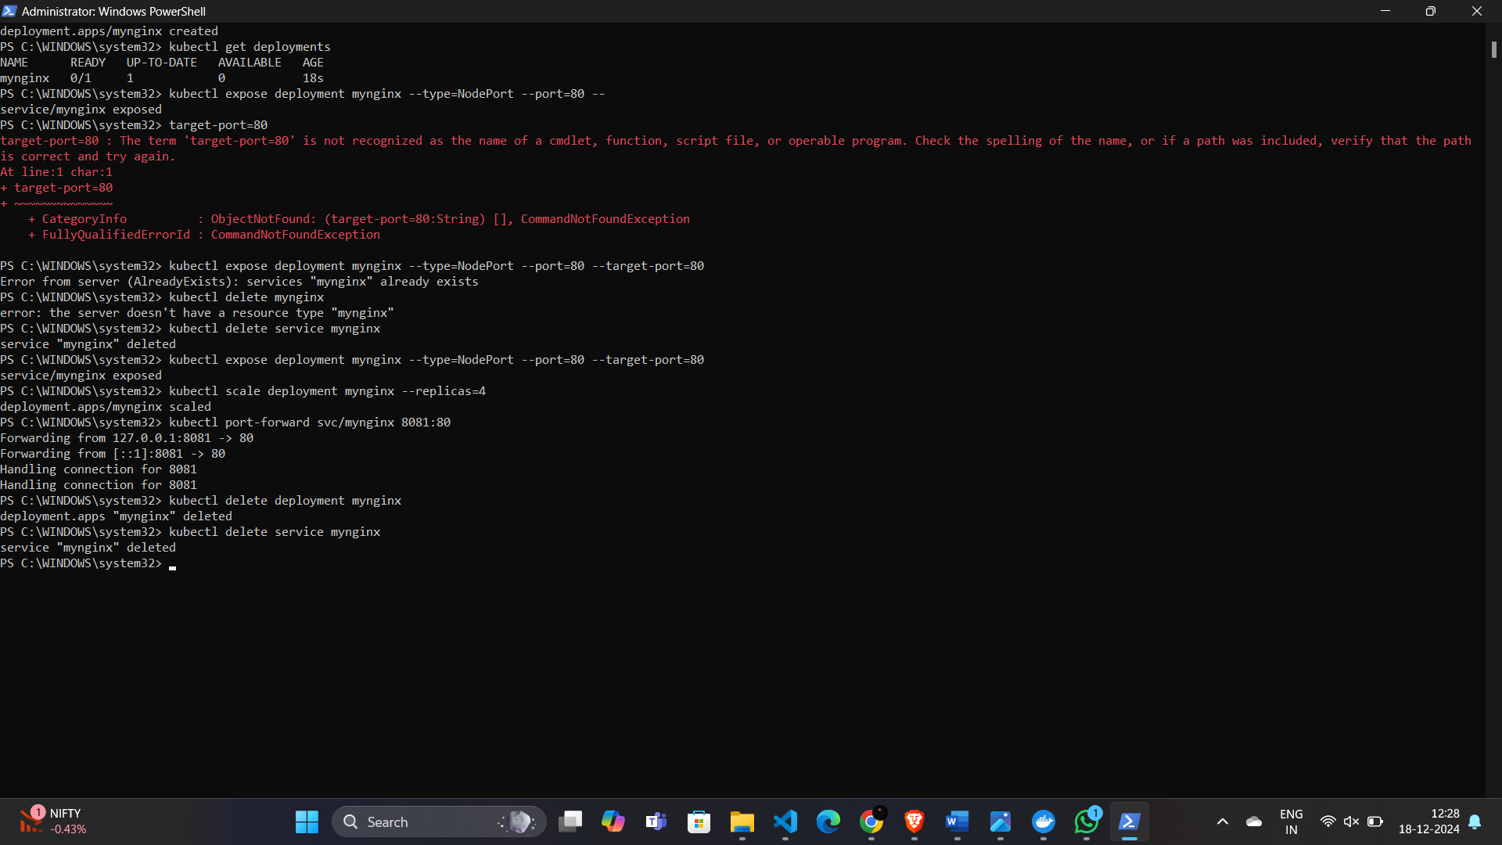

**Minikube stop**

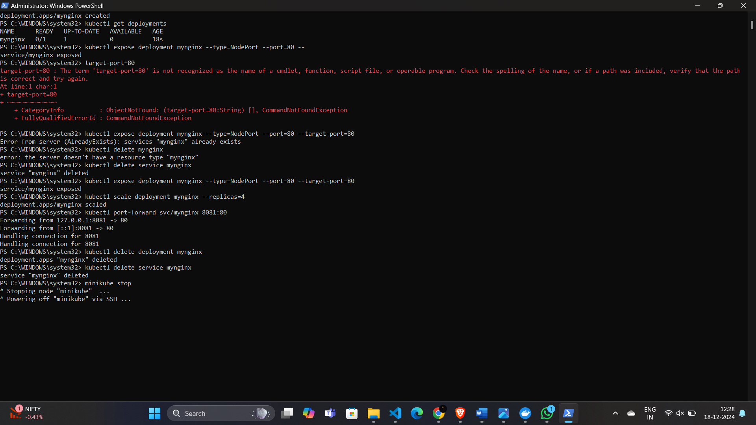

**Minikube delete**

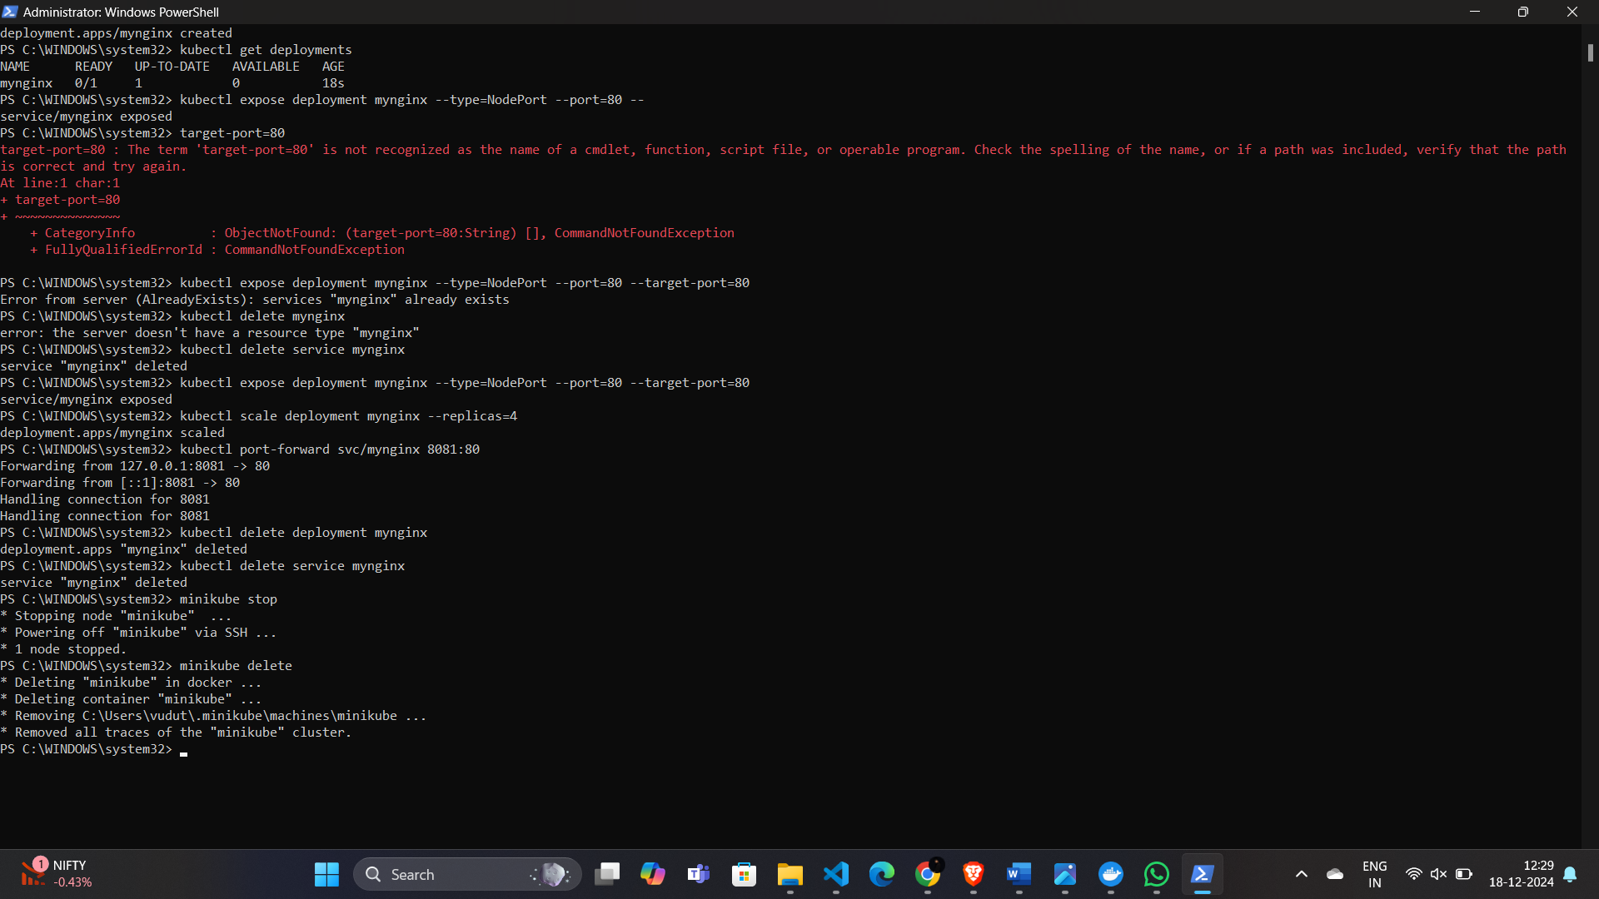

**AND DONE!!**